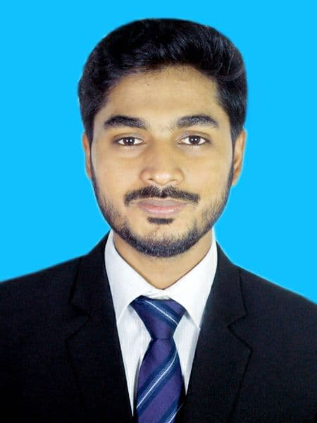**MOHAMMED LOKMAN HOSSEN**

*Kader Bhaban, 3rd floor, Road No. 01, A-block, Chandgaon Residential Area, Chandgaon, Chattogram, Bangladesh*

*Contact No.: 0 1853 11 84 44, 01521 22 22 58*

*Email: lokman063@gmail.com, lokman63@yahoo.com*

**CAREER OBJECTIVE**

*To secure a challenging role in the IT sector that leverages my strong technical expertise in troubleshooting, Networking, hardware and software. My goal is to utilize my skills and abilities & achieve professional growth while being resourceful, innovative & flexible. I am committed to staying up-to-date with the latest technologies and trends in the field to enhance my skills and deliver optimal results for the organization.*

**WORK HISTORY**

* **Executive - ICT**

***Pacific Jeans Limited. Chattogram***

July ,2024 -present

Duties/Responsibilities:

* Ensure the smooth running of all IT systems,
* including anti-virus software, print services,
* Email provision and ensure the security of data from internal and external unauthorized access.
* Provide technical support for both hardware and software issues of our users.
* Network troubleshooting, network maintenance and network cabling.
* Assist to implement LAN/WAN/Internet/Intranet connectivity for remote locations and design
* Systems for those locations to maintain the entire internet/intranet from a central point.
* Update and upgrade user`s PCs as per new requirement.
* Maintain IT asset register. Any other task assigns by the Management.
* **Executive - IT**

***Clifton Group, Chattogram***

March, 2022 – June, 2024 (2.3 years)

*Responsible for below factory:*

1. Clifton Cotton Mills Ltd.

2. Clifton Apparels Ltd. (Knitting)

3. Kith Fashion Ltd.

4. Clifton Paper Mills Ltd.

5. Clifton Apparels Printing Ltd.

* Administer network and data security, Data Backup, including directory, group policy, firewalls, virus

Protection, and email security & Maintain documentation of the network infrastructure, configurations, and

Procedures.

* Installing and configuring computer hardware, software, systems, networks, CCTV, printers and scanners
* Install and update network system improvements, Install and configure Router, Switches & wireless

Networking equipment

* Install and maintenance Active Directory, DNS & DHCP server.
* Monitor servers, LAN/WAN, AP and Wi-Fi to ensure full coverage & CCTV system maintenance &

Troubleshooting

* Install, upgrade and troubleshoot different computers on Windows, Linux and Mac.
* Facing Audit and Prepare all documents related to IT
* Troubleshoot hardware and software problems, both workstation and server
* Provide Network IT support to end-users for their desktops, laptops, network connections, scanners, printers

& Other IT assets.

* Collaborate with the ISP to resolve network-related incidents and support requests.

**SKILLS**

**Programming Languages :** Laravel, PHP, PHP with OOP, HTML, CSS, Bootstrap, JavaScript, jQuery, JAVA, C.

**Database :** MYSQL

**Operating System :** Windows

**Software :** Microsoft Office (word, excel, PowerPoint, outlook), Cisco packet tracer, MATLAB,

CST, phpstorm, Adobe Photoshop, Adobe Illustrator.

**EDUCATIONAL QUALIFICATIONS**

**Bachelor of Science (BSc) in Electronics Telecommunication & Engineering Passing Year-2021**

*International Islamic University Chittagong (Chattogram, Bangladesh)*

**Current CGPA:** 3.273 (out of 4.00)

**Higher Secondary Certificate (HSC), in Science Background Passing Year-2015**

*Hazera Taju Degree College (Chattogram, Bangladesh)*

**GPA:** 3.83 (out of 5.00)

**Secondary School Certificate (SSC), in Science Background Passing Year-2013**

*Chandgaon N.M.C Adorsha High School (Chattogram, Bangladesh)*

**GPA:** 4.63 (out of 5.00)

**PROFESSIONAL TRAINING SUMMERY**

CATIONAL QUALIFICATIONS

**Training Program on PHP Under SEIP**

Duration : 3 Months

Organized By : Bangladesh Association of Software and Information Services (BASIS)

Institution : BASIS Institute of Technology & Management (BITM), Chittagong

**Web Design**

Duration : 3 Months

Organized by : Erevo Technologies Limited

Institution : Erevo Technologies Limited, Chittagong

**Web App Development (basic php & Laravel)**

Duration : 3 Months

Organized by : Erevo Technologies Limited

Institution : Erevo Technologies Limited, Chittagong

**Cisco Certified Network Associate (CCNA)**

Duration : 3 Months

Organized by : Erevo Technologies Limited

Institution : Erevo Technologies Limited, Chittagong

**Mikrotik Basic Course**

Duration : 3 Days

Organized by : Erevo Technologies Limited

Institution : Erevo Technologies Limited, Chittagong

**Spoken in English**

Duration : 3 Months

Organized by : Grey Goose English Studio

Institution : Grey Goose English Studio, Chittagong

**LANGUAGE PROFICIENCY:**

✓ Bengali (Native)

✓ Have good command in communicative and written English

Reference: 2

**Kazi Md. Shahed Hossain**

*Managing Director*

*Erevo Technologies Ltd.*

*E-mail:* [*shahed101025@gmail.com*](mailto:shahed101025@gmail.com)

*Mobile: 01730150991*

*Reference: 1*

**MD. SHAHIDUL ISLAM SARKER**

**Manager - ICT, SYSTEMS & NETWORK**

*Pacific Jeans Ltd., Chattogram*

*Email: -* [*Shahidul.Sarker@pacificjeans.com*](mailto:Shahidul.Sarker@pacificjeans.com)

*Mobile: 01712216618*

**REFERENCES**

**PROCLAMATION**

I do hereby declare that all information presented in this curriculum vitae is correct to the best of my knowledge.



Mohammed Lokman Hossen